19CSE305 - Machine Learning

Case Study

HAND GESTURE DETECTION

**INDEX**

|  |  |
| --- | --- |
| CONTENT | PAGE NO |
| INTRODUCTION | 1-3 |
| BLOCK DIAGRAM AND ALGORITHM | 4-7 |
| INFERENCE OF RESULT | 8-10 |
| CONCLUSION | 11-12 |

**INTRODUCTION :**

Hand gesture detection is a field of computer vision and human-computer interaction that focuses on recognizing and interpreting gestures made by the human hand. It involves capturing, analyzing, and understanding the dynamic movements and configurations of the hand to derive meaningful commands or interactions. This technology has gained significant attention due to its potential for creating more natural and immersive interfaces between humans and machines.

Real-World Use Cases:

1.Human-Computer Interaction:

Virtual Reality (VR) and Augmented Reality (AR): Hand gesture detection enhances the user experience in VR and AR environments by allowing users to interact with virtual objects using natural hand movements.

2.Gaming:

Gesture recognition has been widely adopted in gaming, enabling players to control characters, manipulate virtual objects, or perform in-game actions through hand gestures.

3.Accessibility:

Assistive Technology: Hand gesture detection can be used to assist individuals with physical disabilities by providing them with an alternative and intuitive way to interact with computers or control electronic devices.

4.Smart Devices and Home Automation:

Smart TVs and Set-Top Boxes: Users can navigate menus, adjust settings, or control playback using hand gestures instead of traditional remote controls.

Home Automation Systems: Gesture recognition can be applied to control smart home devices, such as lights, thermostats, and security systems.

5.Healthcare:

Surgeon Assistance: In surgery, hand gestures can be used to control digital displays or access medical information without the need for direct physical contact, maintaining a sterile environment.

Rehabilitation: Hand gesture detection is employed in rehabilitation exercises, allowing healthcare professionals to monitor and guide patients through therapeutic movements.

6.Retail and Marketing:

Interactive Displays: Gesture recognition can create engaging and interactive displays in retail settings, allowing customers to navigate product information or virtual catalogs using hand gestures.

7.Education:

Interactive Learning: In educational environments, hand gesture detection can enhance interactive learning experiences, enabling students to interact with digital content in a more engaging manner.

8.Industrial Applications:

Control Systems: Hand gestures can be used to control robotic arms or machinery in industrial settings, improving efficiency and safety.

In summary, hand gesture detection has a wide range of practical applications that extend beyond entertainment and gaming. As technology continues to advance, the integration of gesture recognition into various aspects of our daily lives holds the potential to create more seamless and user-friendly interactions between humans and machines.

**ALGORITHM:**

**1.K-Nearest Neighbors (KNN):**

Type: Supervised Learning (Classification)

Use in Hand Gesture Detection:

KNN is a simple and intuitive algorithm used for classification tasks.

In hand gesture detection, KNN can be applied by associating each gesture with a class, and a new gesture is classified based on the majority class of its nearest neighbors in the feature space.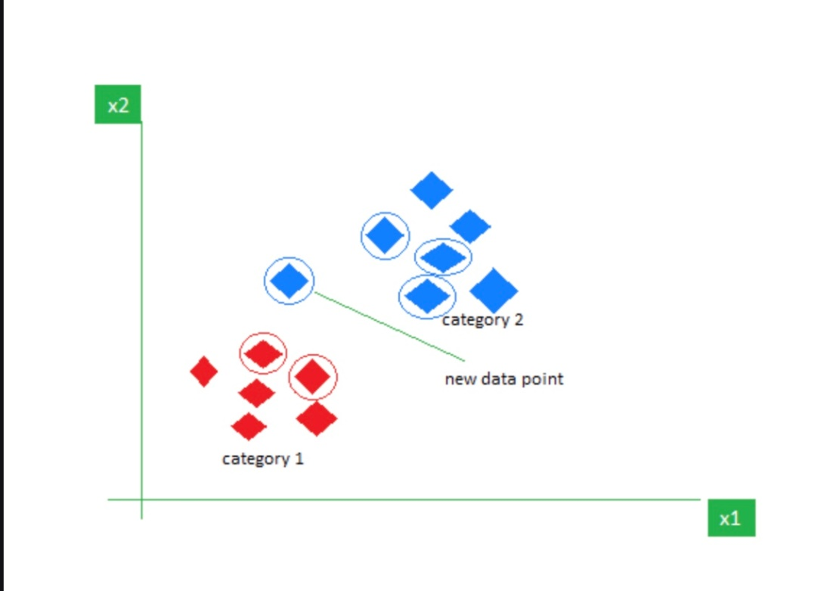

**2.Random Forest:**

Type: Ensemble Learning (Bagging)

Use in Hand Gesture Detection:

Random Forest is effective for high-dimensional data and resistant to overfitting.

In hand gesture detection, it can be employed to build an ensemble of decision trees, each trained on different subsets of the data, improving accuracy and robustness.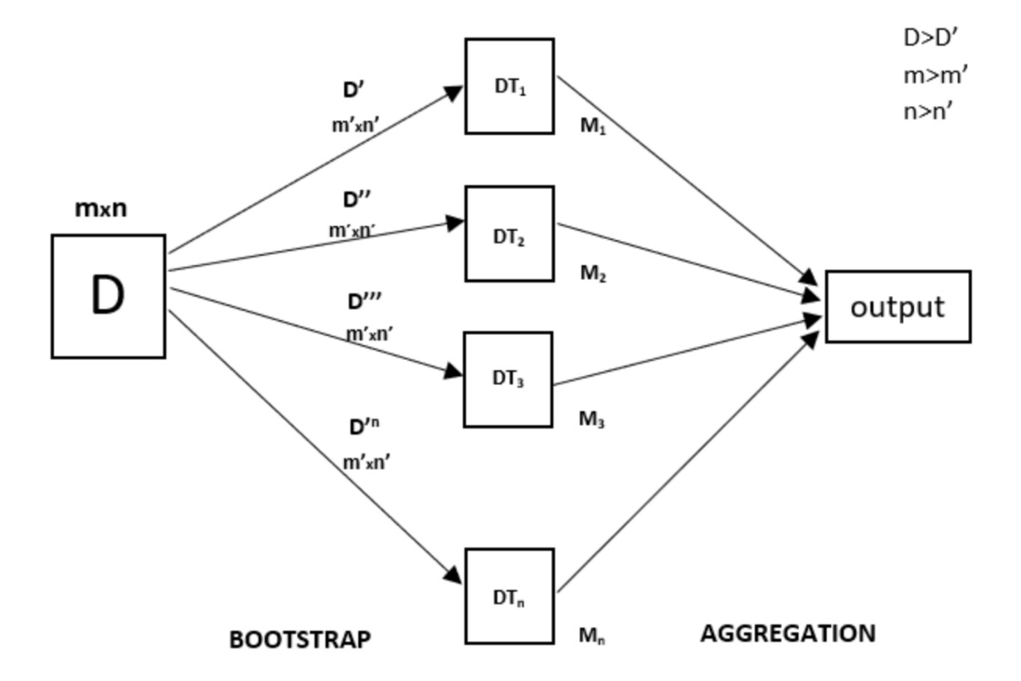

**3.K-Means:**

Type: Unsupervised Learning (Clustering)

Use in Hand Gesture Detection:

K-Means is primarily used for clustering, which may not be a direct fit for hand gesture detection.

However, it can be applied in feature space analysis or for grouping similar gestures during preprocessing.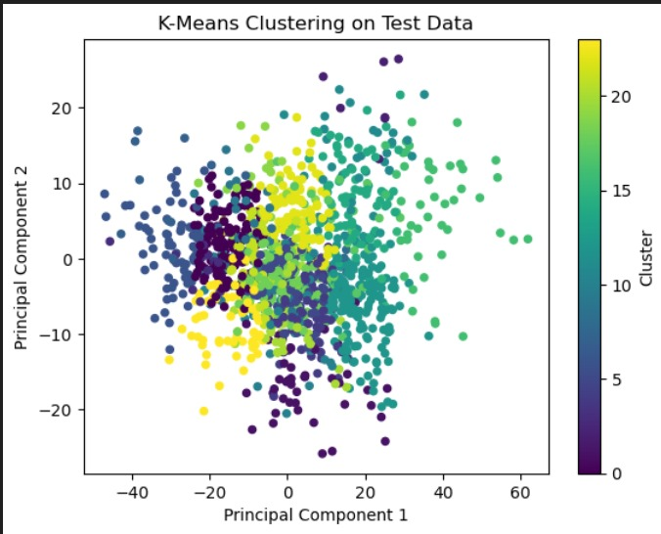

**4.Convolutional Neural Networks (CNN):**

Type: Deep Learning

Use in Hand Gesture Detection:

CNNs excel in image-related tasks and hierarchical feature learning.

In hand gesture detection, CNNs can be trained on image data, automatically learning spatial hierarchies of features, making them well-suited for recognizing patterns and shapes in hand gestures.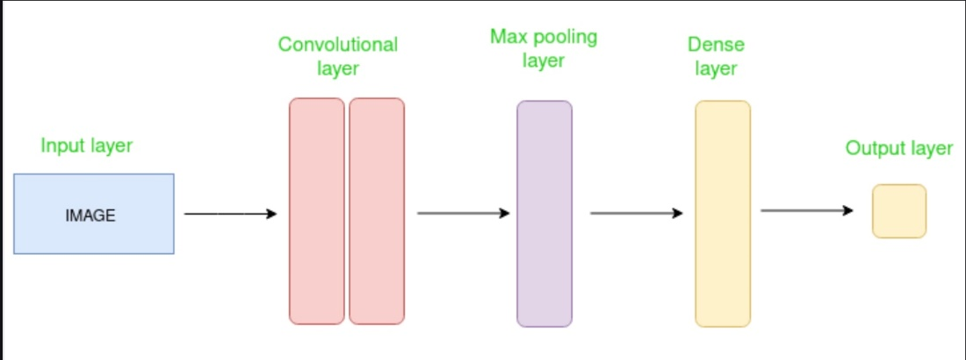

**5.Support Vector Machines (SVM):**

Type: Supervised Learning (Classification)

Use in Hand Gesture Detection:

SVMs are effective in high-dimensional spaces and are particularly useful when there is a clear margin of separation between classes.

In hand gesture detection, SVMs can be employed for classifying different gestures based on their features in the input space.

Each algorithm has its strengths and weaknesses, and the choice depends on factors like the nature of the data, the complexity of the gesture recognition task, and the computational resources available. In recent years, deep learning approaches, especially CNNs, have gained popularity in image-related tasks, including hand gesture detection, due to their ability to automatically learn complex features from data.

**BLOCK DIAGRAM:**

**INFERENCE OF RESULT:**

Aplhabets starting from A to Z.

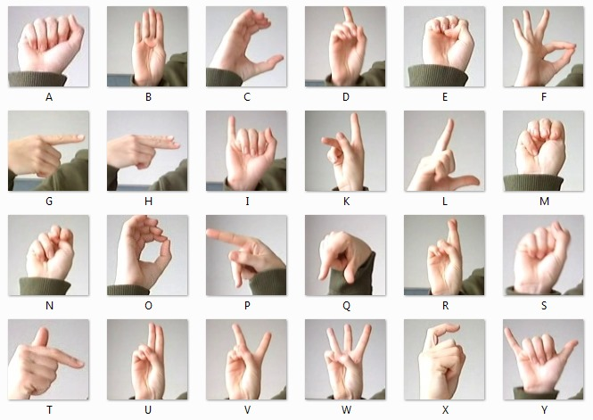

Checking the input and mapping it to the corresponding dataset:

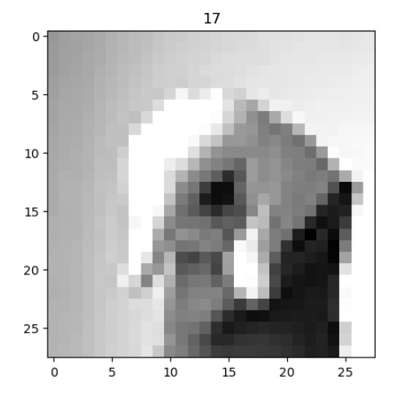

Output:

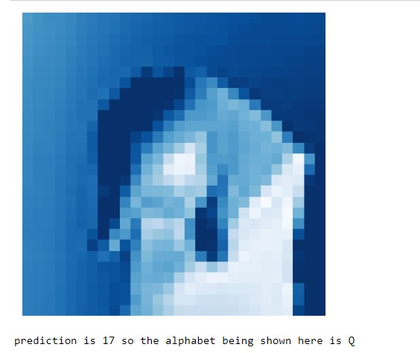

CONCLUSION:

In conclusion, selecting the most suitable algorithm for hand gesture detection depends on various factors such as the complexity of the task, the characteristics of the data, and the computational resources available. Each algorithm—K-Nearest Neighbors (KNN), Random Forest, K-Means, Convolutional Neural Networks (CNN), and Support Vector Machines (SVM)—offers unique advantages in the context of hand gesture recognition.

KNN provides a simple and intuitive approach, relying on the majority class of nearest neighbors for classification.

Random Forest is robust and effective for high-dimensional data, making it suitable for ensemble-based classification in hand gesture detection.

K-Means, while primarily a clustering algorithm, may find application in grouping similar gestures during preprocessing.

CNNs, as a deep learning approach, excel in capturing complex hierarchical features in image data, making them well-suited for recognizing patterns and shapes in hand gestures.

SVMs are effective in high-dimensional spaces and work well when there is a clear margin of separation between gesture classes.

The choice of algorithm often involves a trade-off between simplicity, interpretability, and the ability to capture intricate patterns in the data. In recent years, deep learning methods, particularly CNNs, have demonstrated remarkable success in image-related tasks like hand gesture detection, where the data is complex and rich in spatial features. Ultimately, the selection should be based on the specific requirements and characteristics of the hand gesture recognition task at hand. Experimentation and thorough evaluation on the target dataset are essential to determine the most effective algorithm for a given application.

**REFERENCES :**

1. <https://journalofbigdata.springeropen.com/articles/10.1186/s40537-022-00571-w>

2. <https://huggingface.co/papers/2307.16686>

3. <https://www.sciencedirect.com/science/article/pii/S2590123023002347>

4. <https://content.iospress.com/articles/ai-communications/aic210172>

5. <https://www.youtube.com/watch?v=aaP7JJZuvGs&t=99s>

6. https://www.kaggle.com/datasets/datamunge/sign-language-mnist

7. https://www.youtube.com/watch?v=c6otdpVMtXw